VPC TASKS-02
- Create one VPC, with 1 public subnet and 1 private subnet.
Go to vpccreate one vpcafter go to subnetscreate publickeys and private keys

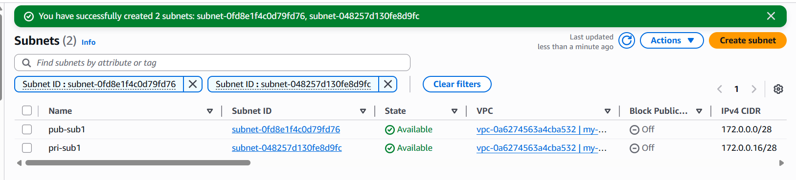
- Enable VPC peering for cross-region.
In this vpcafter creating subnetsopen route tables and create route tables for private and public keys separatethen go to internet gateway create IGW for public keysgo to route tables open subnet assosiactions save assoedit routes select enter integrate way was entered successfullypeering connectionFrom ohio to N.virgina give that regionconnect the ohio pem to git bashping ip address of n.virgina we have connection of peering successfully.

Create 2 subnets 1 pri and 1 pub subnet in ohio
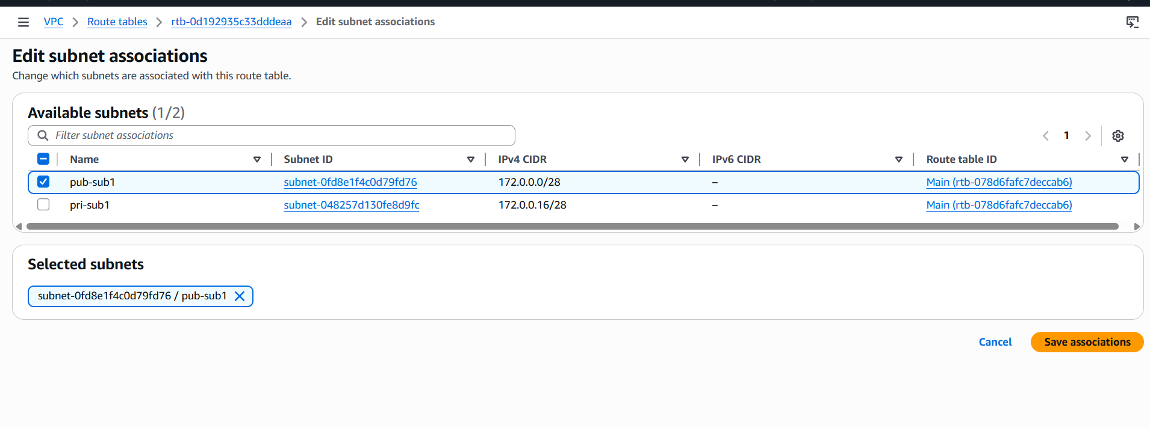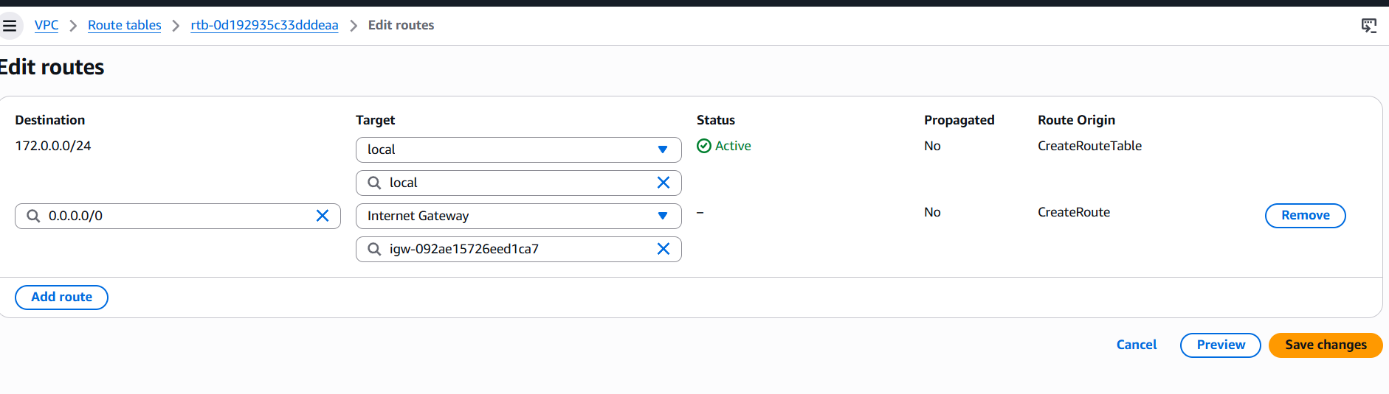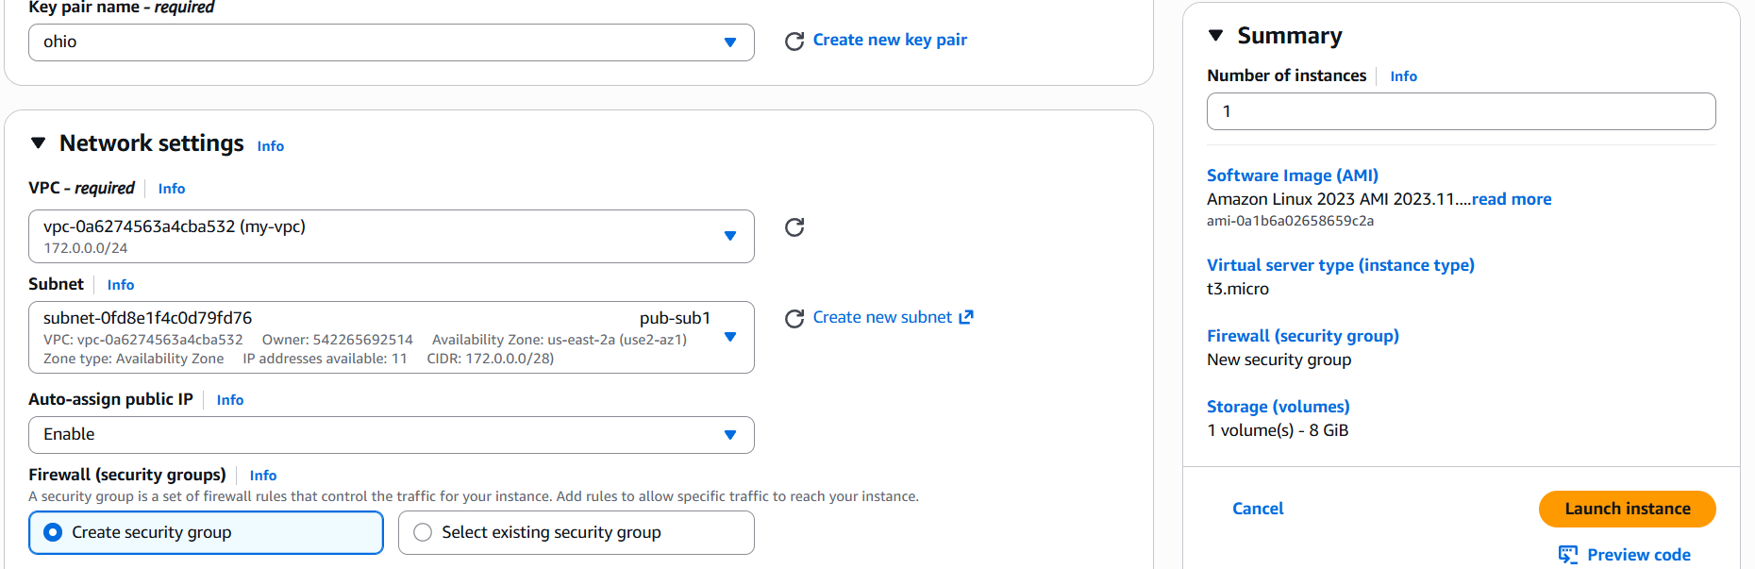
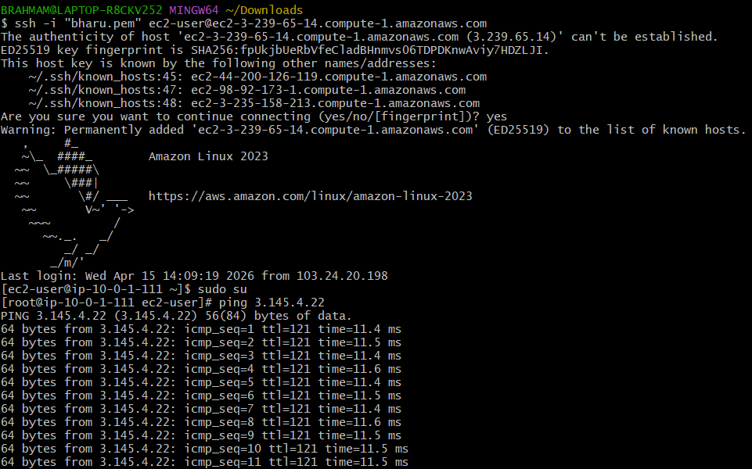
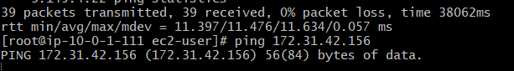
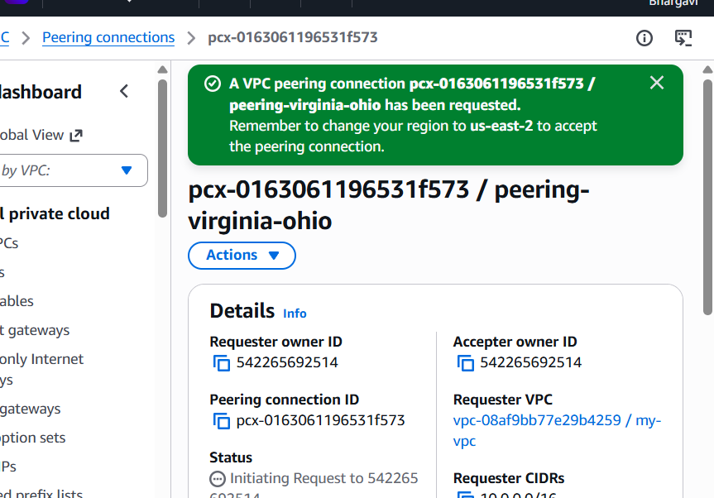
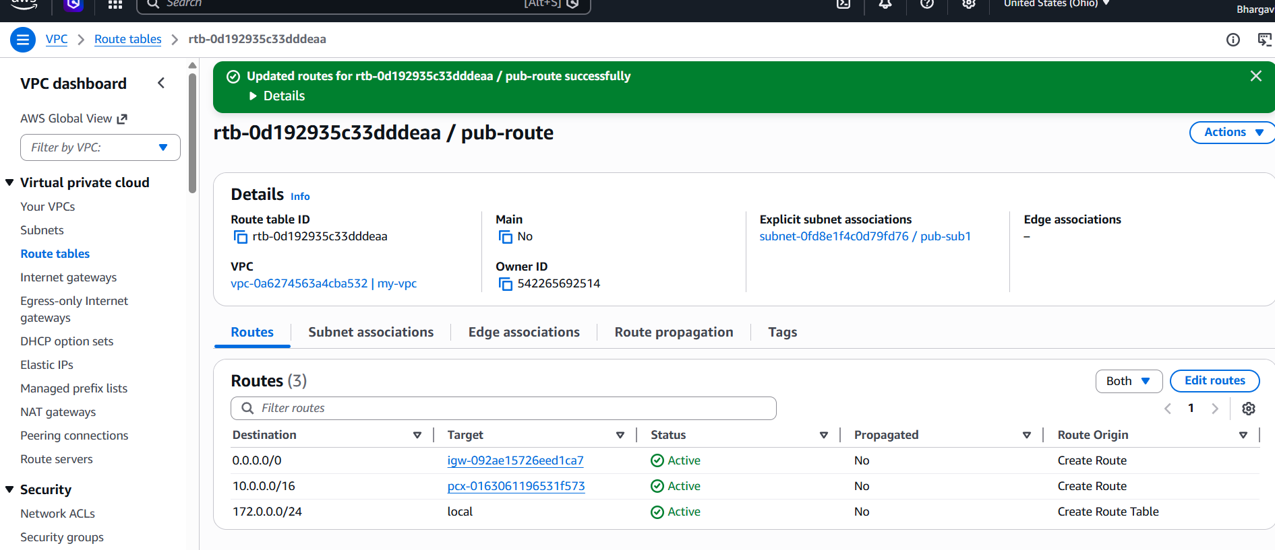
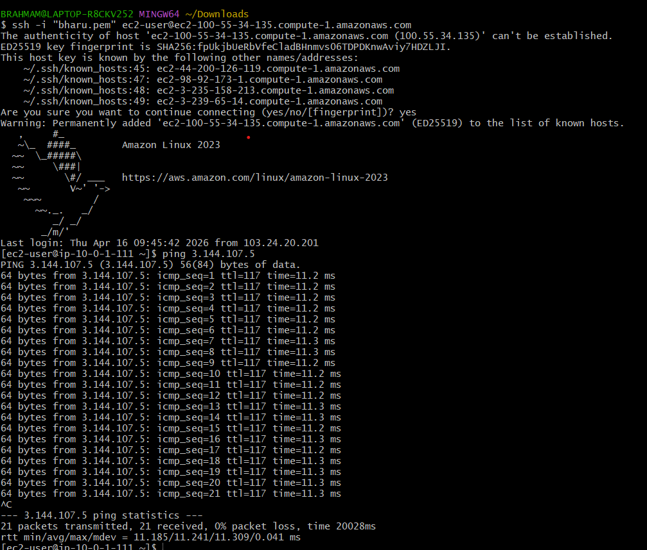
- Enable VPC peering for cross-account (you can collaborate with your friend to do this task).
In this I have to open the vpc peering connectionsselect myvpcanother accountanother region here I can give my fri account id and vpcidconnection of peering successfullymy fri go to their route table and add my cidr number in their vpcand now connect my public instance to git bashping friend pub ip addresssuccesfully running.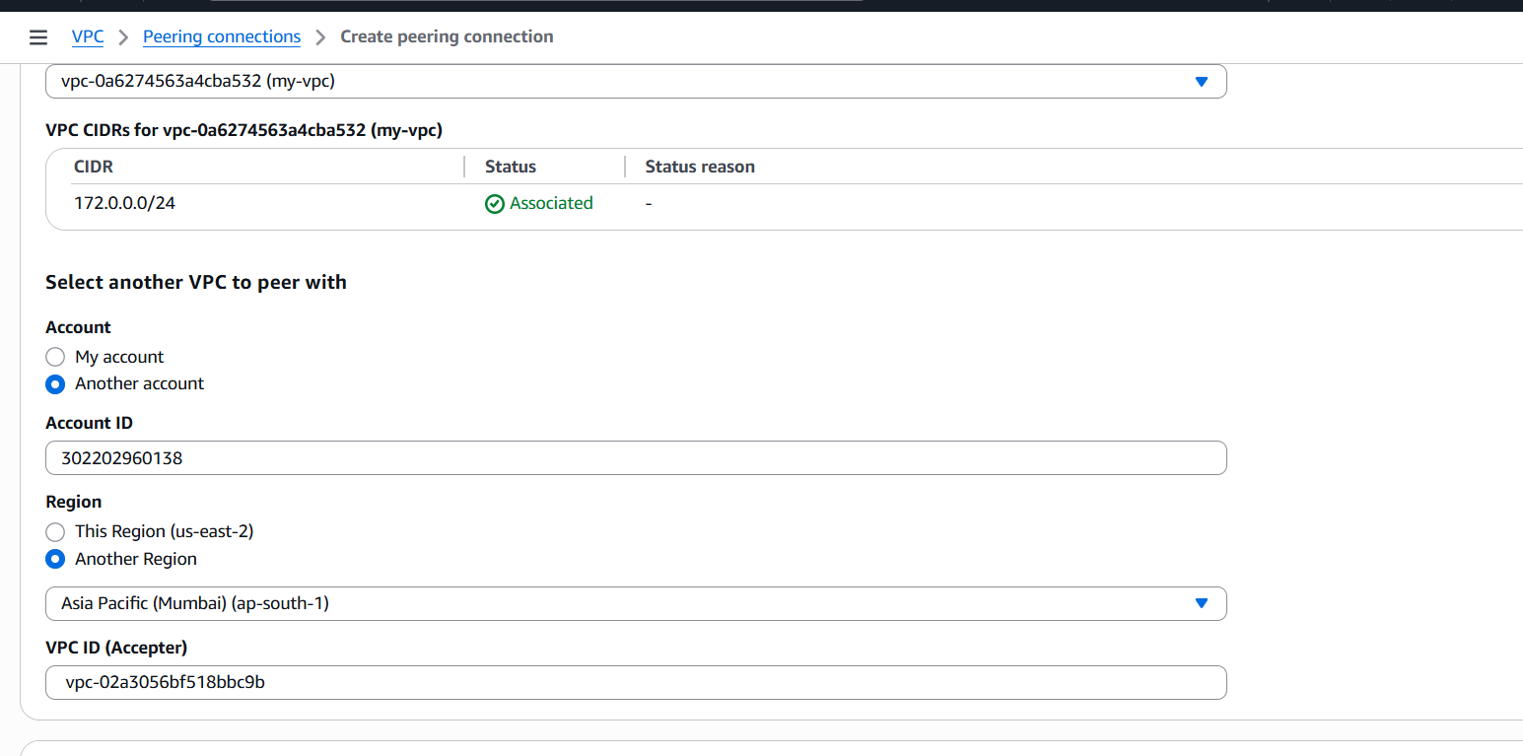
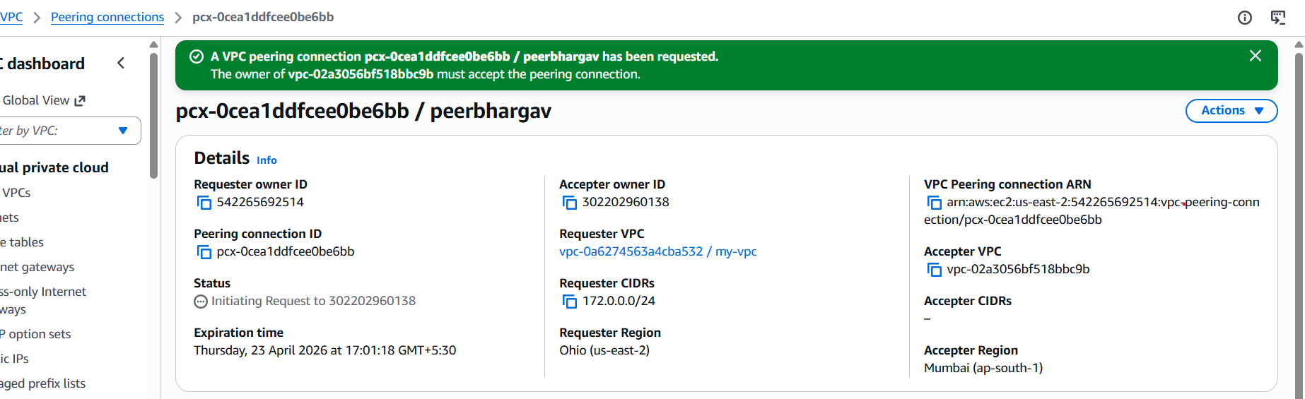
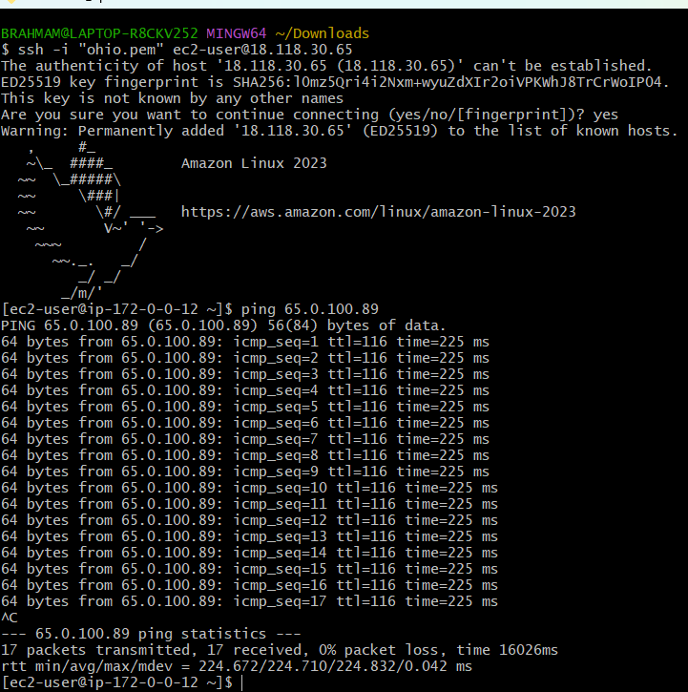
- Set up a VPC Transit Gateway
Create multiple vpc in the region with public subnets and total
Configuration.

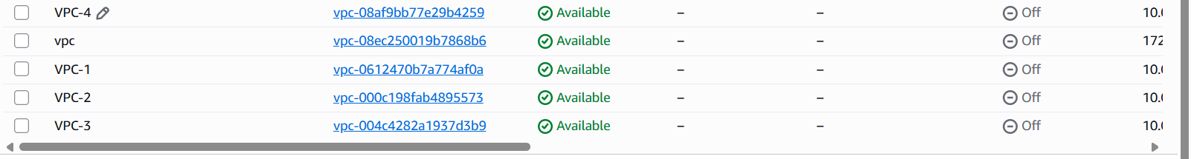
Next create route tables for every vpc.
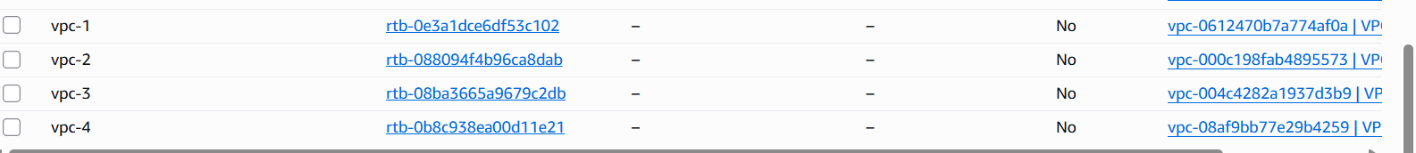
After completing route tables creatinginternet gateway was created for every vpcthat vpc has attached or detached see once go to subnet associations created successfullyafter created then we want to give routes connection to route tables in with igw
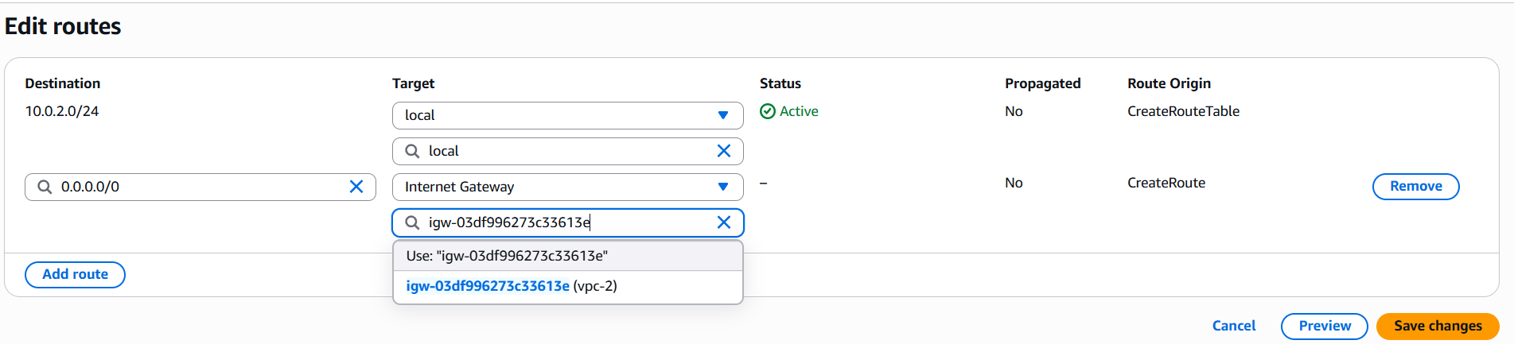
Create transit gateways
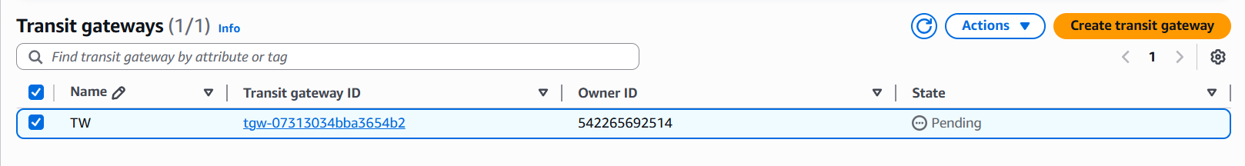
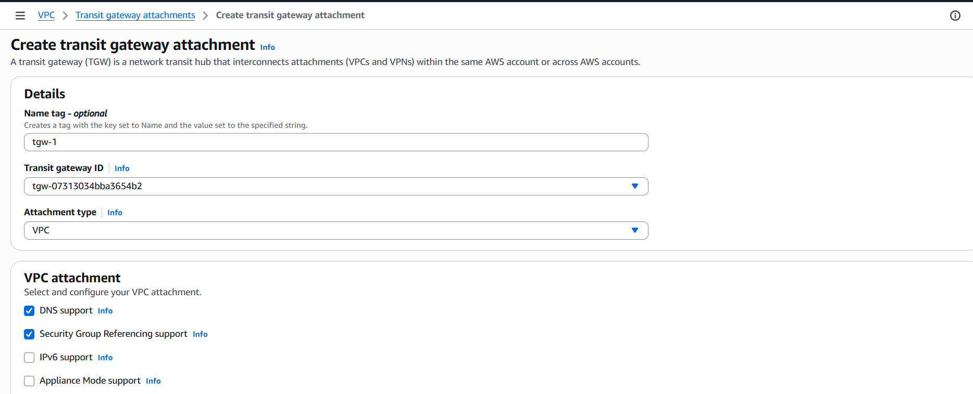
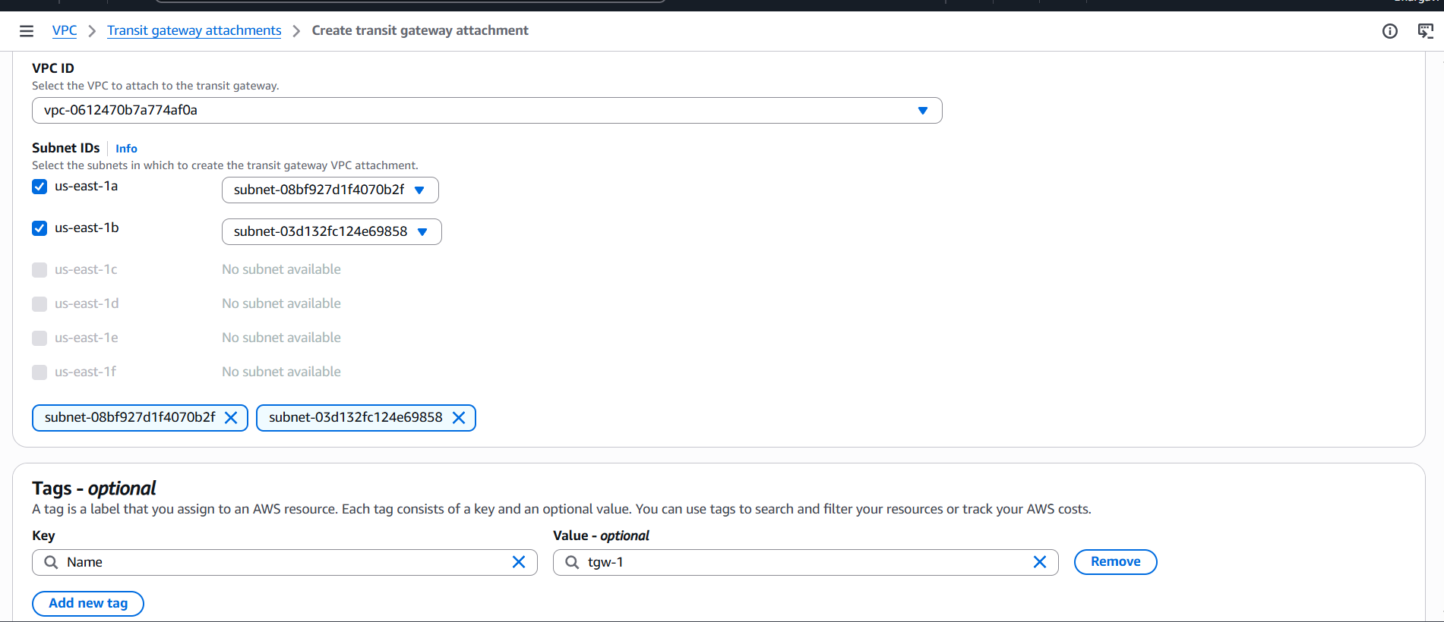
Now I created every transit gateway attachements different different vpcs with different transit attachements after completed attachements I want to check the connections are associated or not.
check below transit gateway route tables
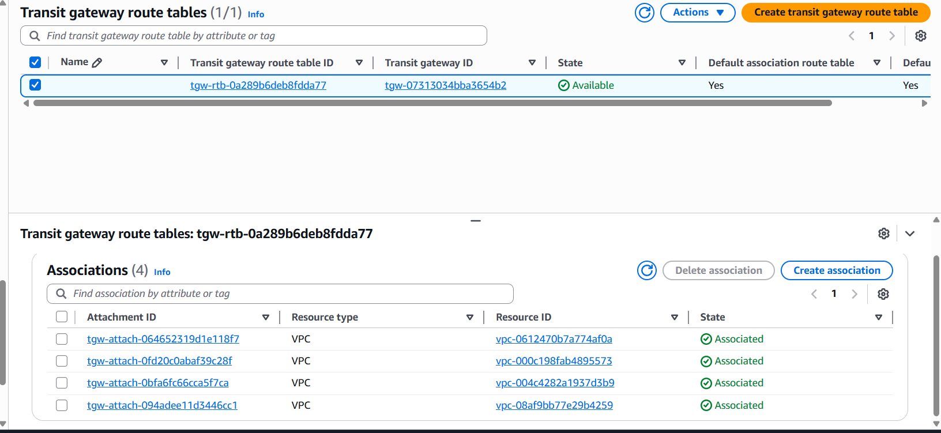
Go to route tables and add any vpc have to connect all extra three cidr numbers with transit gateway id shown in below
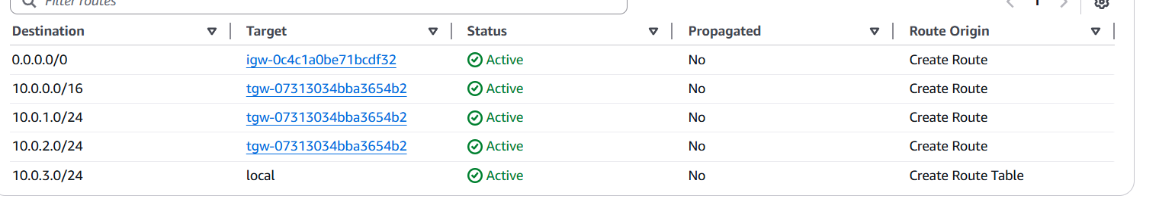
I created transit gateway to given vpcs and now I created instances
four instances I am showing only 2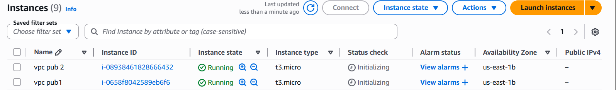
Now go to git bashconnect instance ping ip address of public address of another vpc
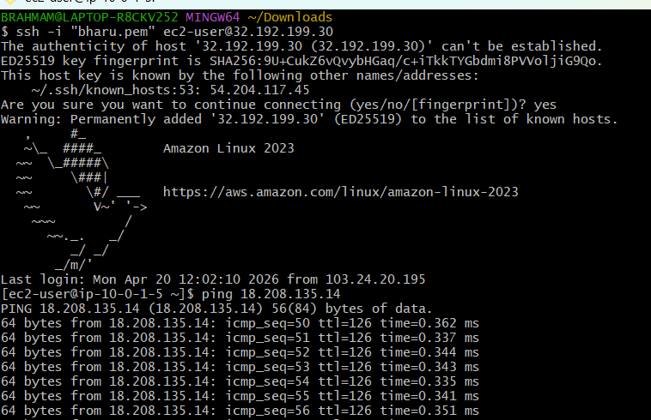
5.set a VPC endpoint
Create a endpoint
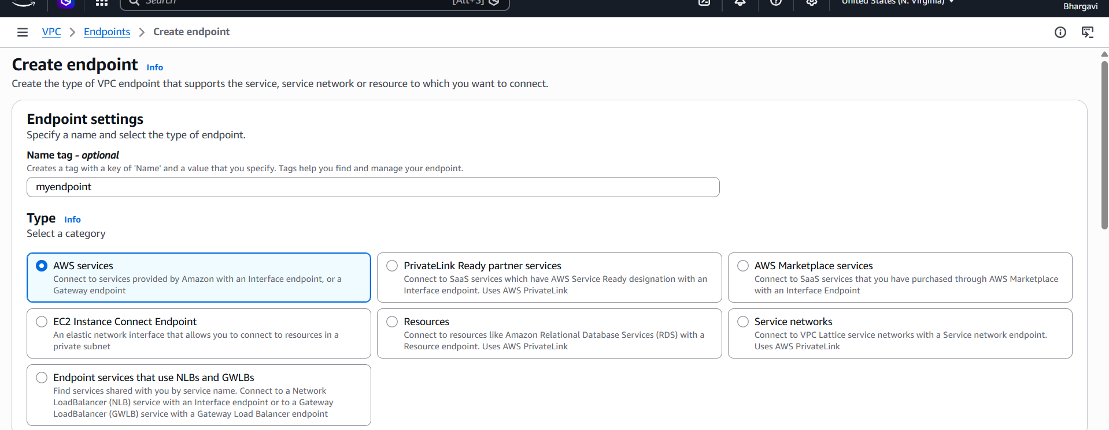
We can take s3 bucket
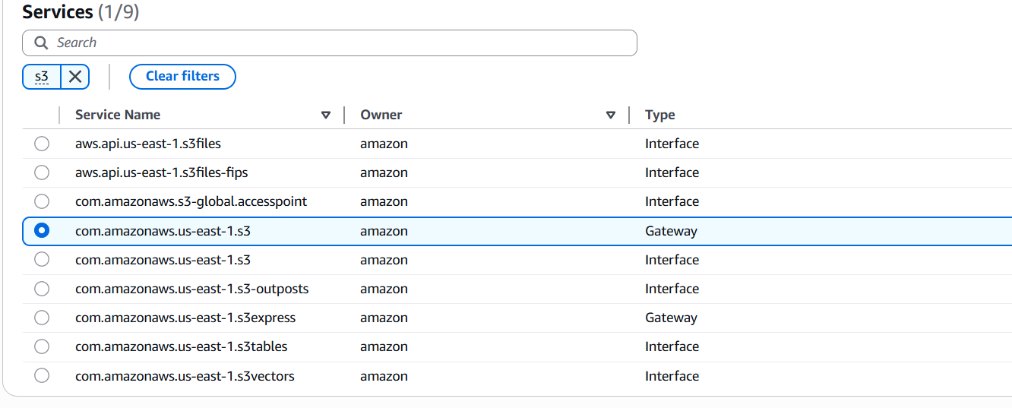
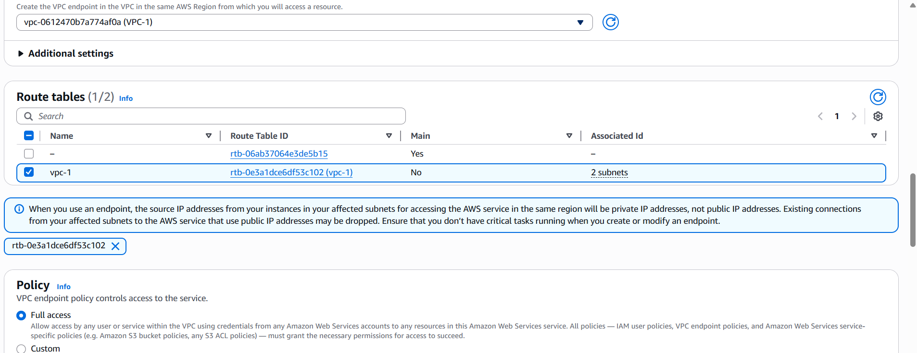
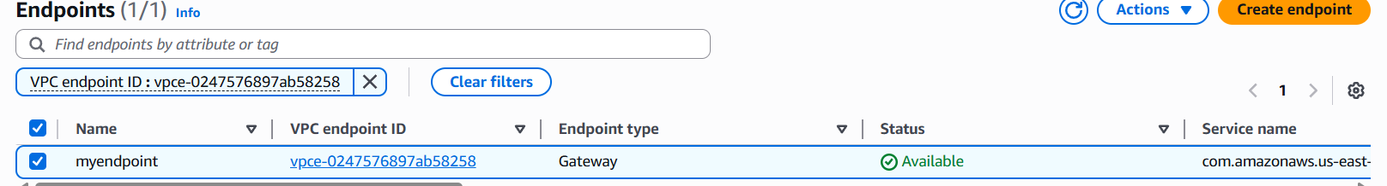
We have to see here destination pi adress
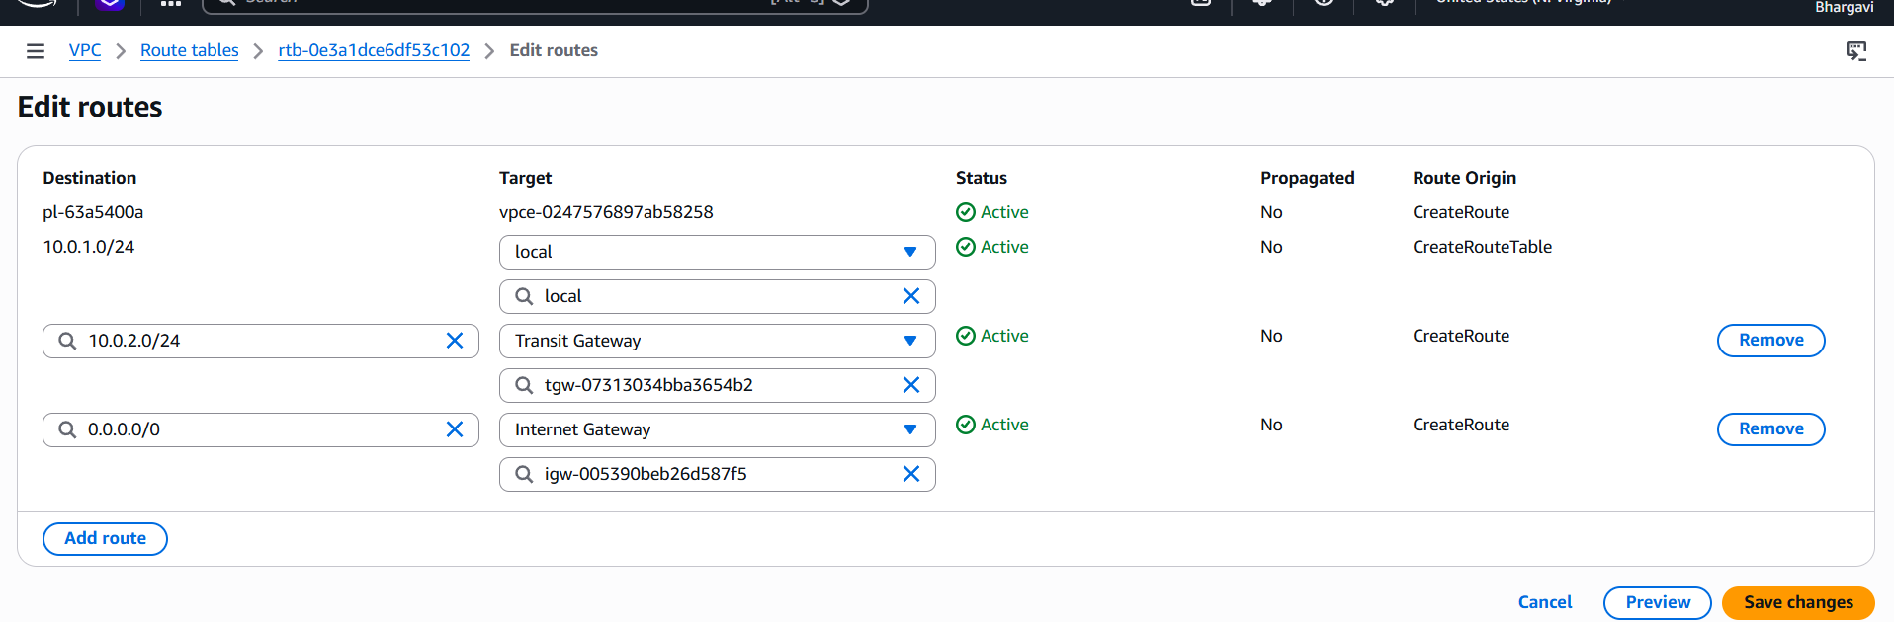
Then go to our account id and select credentialsselect access key pairdownload.csv filego to git bash and connect with the any instance
aws configureaccess key id shown in below.

